Unit Testing Document
SAP
Financial Accounting & Reporting

Test case: Transaction
The process begins when a transaction is initiated from the application—either manually or automatically. The system then posts the corresponding accounting entries. The screenshot below shows an example of a transaction that was posted manually using the FUNDS.TRANSFER functionality.
Following is the screenshot of the account which will be credited in the manual transaction.
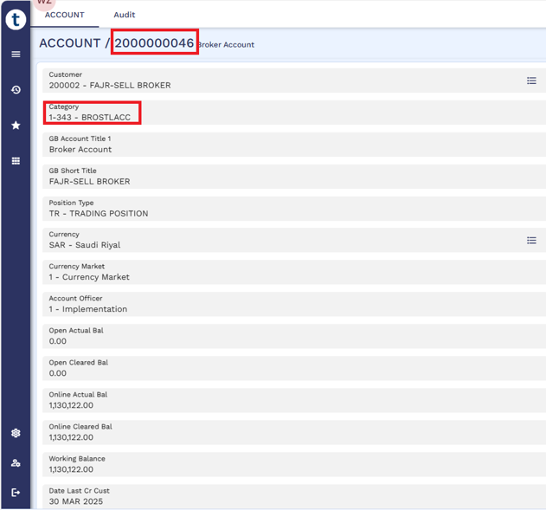
The above screenshot shows the product in which the account has been created.
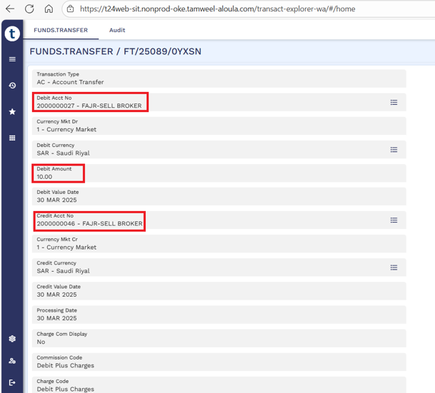
An account transfer amounting SAR10 was done between two accounts. The credit account was 2000000046.
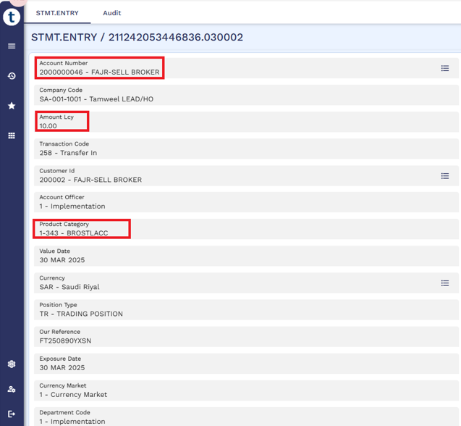
The credit leg of the accounting entry is displayed in the above screenshot of the STMT.ENTRY table. It shows the account that was credited, the credited amount, and the product category under which the account was created.
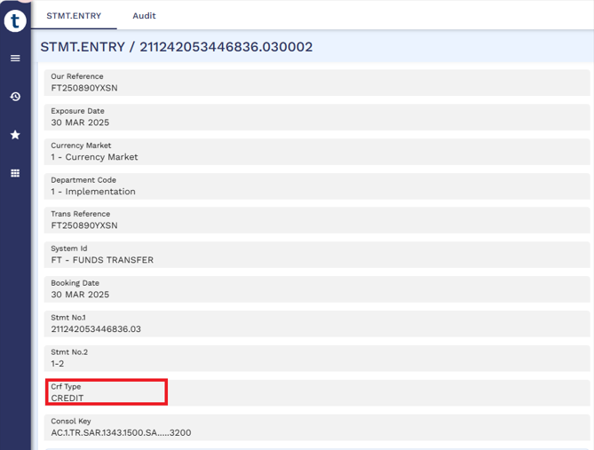
Furthermore, the above screenshot from the STMT.ENTRY table, corresponding to the same entry shown previously, displays the balance type of the transaction.
Once the transaction is posted, the SAP interface cross-references the product category and asset type from the entry table with the RE.STAT.REP.LINE table.
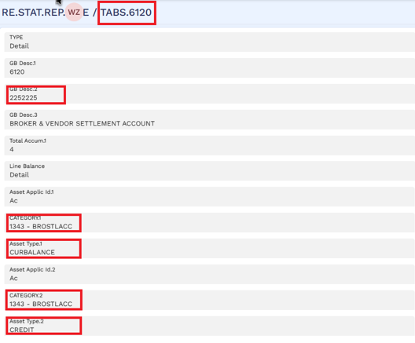
When the configuration of a line matches the product category and asset type recorded in the entry, a link is established. The routine then retrieves the record ID of the identified line and extracts the corresponding SAP GL code from the DESC2 field, as shown in the screenshot above.
Once the GL code is identified, the transaction details are stored in the EB.SMBT.H.SAP.TRANSACTION table, as shown in the screenshot below.
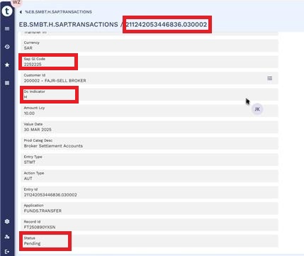
The above screenshot displays the transaction details stored in the EB.SMBT.H.SAP.TRANSACTION table for the credit leg of the accounting entry. It shows that the transaction is linked to the corresponding SAP GL code, with the DC indicator set to H, indicating that the identified SAP GL code will be credited in SAP. The record status is shown as Pending, meaning the transaction is ready for posting in SAP but has not yet been processed.
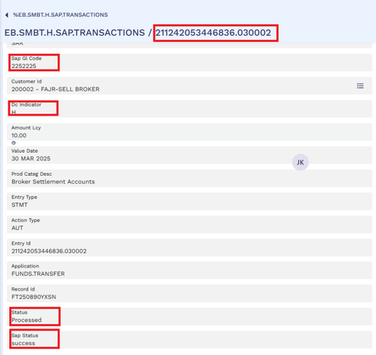
Once the API is triggered and the transactions are posted to SAP, the same record updates its Status field from Pending to Processed. The SAP response is then captured in the SAP Status field, indicating Success, as shown in the screenshot above.

Test case: Customer
The process begins when a customer is onboarded or updated. The system then pushes Customer data.
Following is the screenshot of the Customer which will be Onboarded.
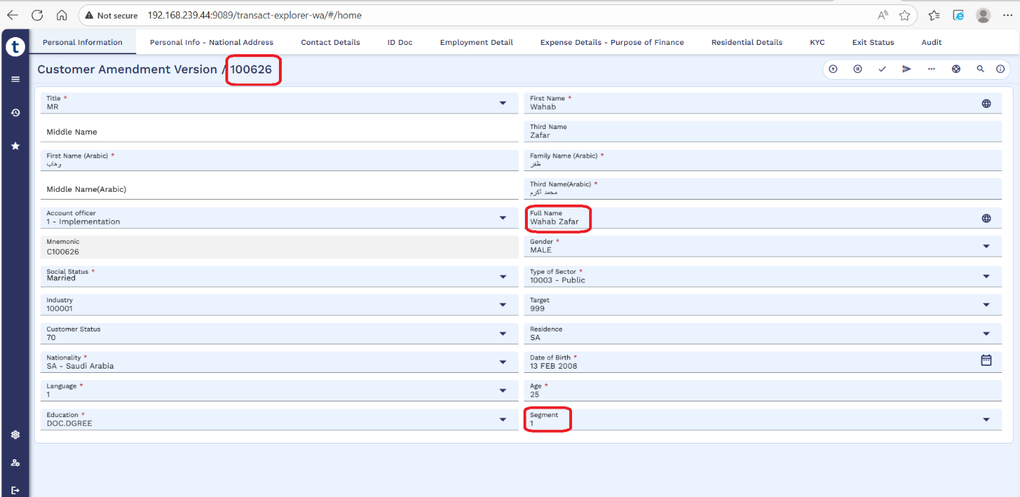
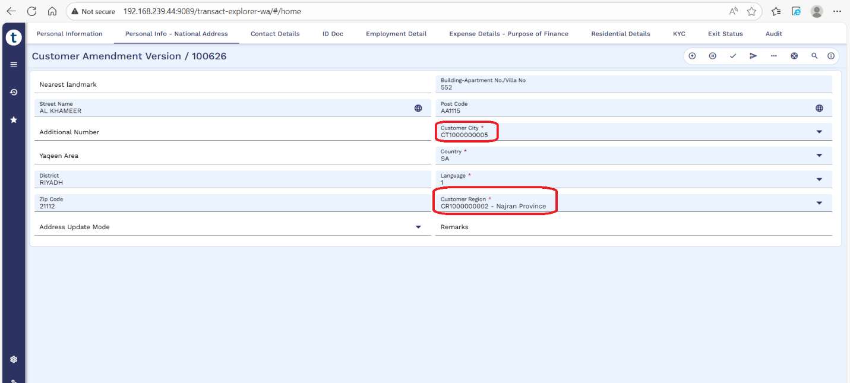
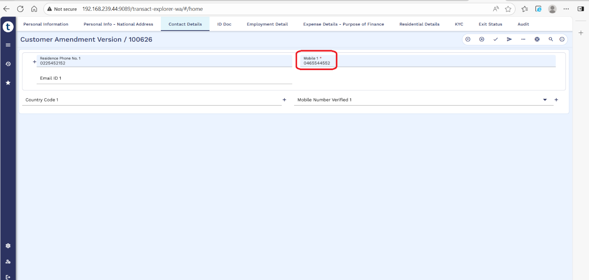

The above screenshot shows the details of Customer which is created on Transact.

Once the Customer is identified, the Customer details are stored in the EB.SMBT.L.SAP.CUSTOMER table, as shown in the screenshot below.
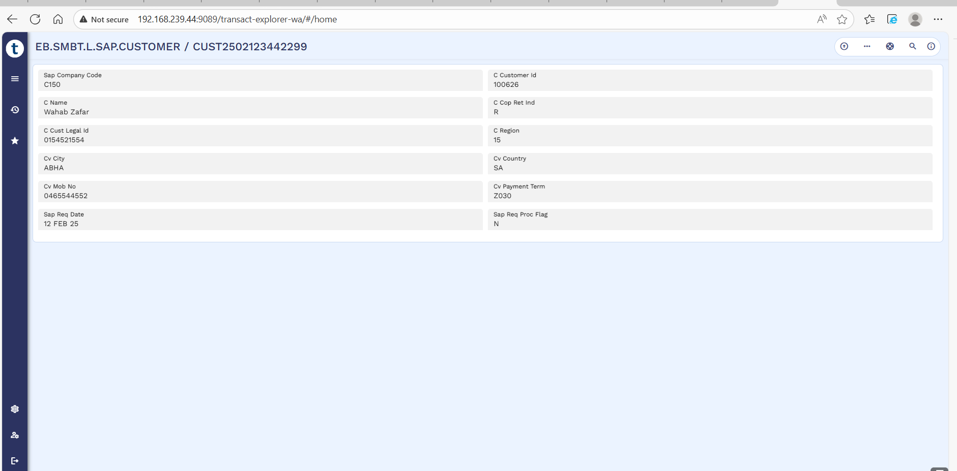

Test case: Vendor
The process begins when a Vendor is created or updated. The system then pushes Vendor data.
Following is the screenshot of the Vendor which will be Created.
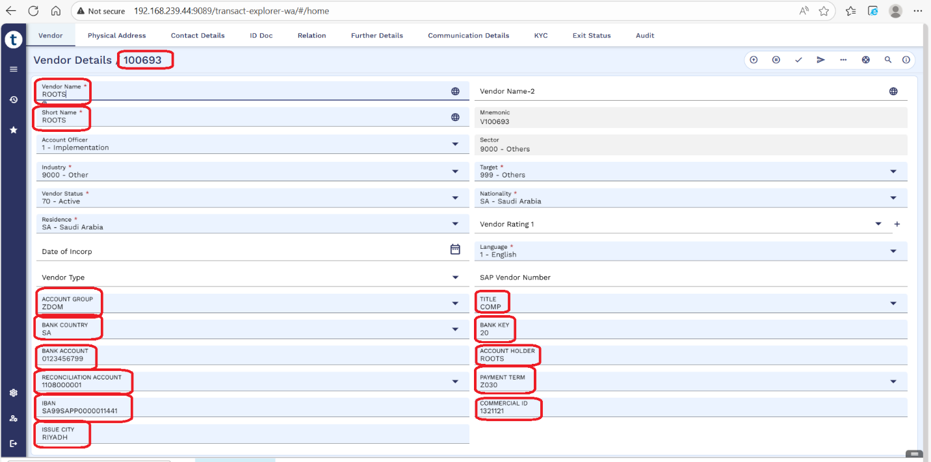
The above screenshot shows the details of Vendor which is created on Transact.
Once the Vendor is identified, the Vendor details are stored in the EB.SMBT.L.SAP.CUSTOMER table,
as shown in the screenshot below.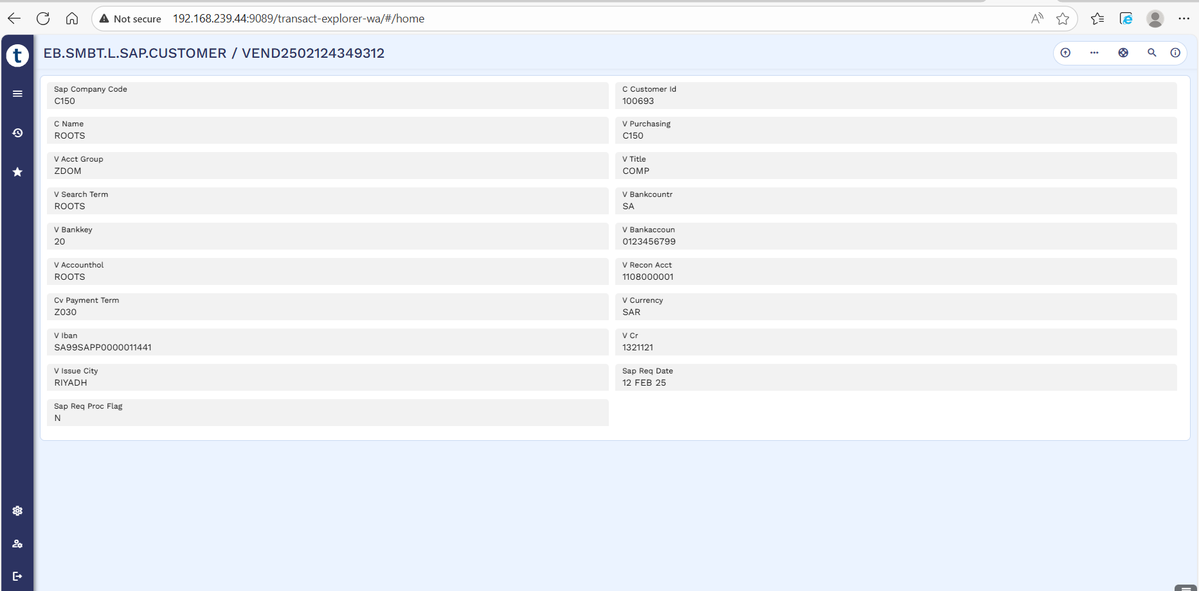
Once the API is triggered, the customer & vendor records stored in EB.SMBT.L.SAP.CUSTOMER are processed are posted to SAP. The SAP response is then captured in the SAP.RESP.STATUS field.

